Kinematics Review Quiz Multiple Choice Questions

1. Which of the following graph(s) does(do) NOT represent uniform motion?
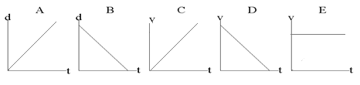

a. | A,B,C and D | d. | A and B
b. | B only | e. | C and D
c. | E only

2. Which of the following are VECTOR quantities?
I. position II. speed III. displacement IV. velocity
a. I and III only d. II, III and IV only
b. III and IV only e. I, III and IV only
c. I and IV only

3. Two hikers set out from the same spot and arrive at the same destination but they take different routes. Which of the following quantities must be the same for both hikers?
a. | displacement | d. | average speed
b. | distance | e. | acceleration
c. | average velocity

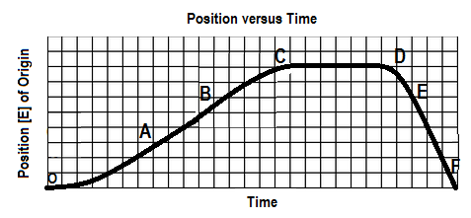
4. The graph below shows a position-time graph

Over which interval is the object moving west and speeding up?
a. OA b. BC c.CD d. DE e.EF

5. The slope of a line drawn tangent to a curved position-time graph represents
a. | displacement | d. | acceleration
b. | instantaneous velocity | e. | distance
c. | average velocity

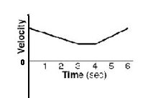

6. A velocity-time graph is shown at right. Which of following best
describes the object’s motion? The object

a. moves backward at a constant velocity, stops, then moves forward at constant velocity.
b. moves forward at a constant velocity, stops, then moves backward at constant velocity
c. slows down uniformly as it moves backward, stops, then speeds up uniformly as it moves forward
d. slows down uniformly as it moves forward, continues at a constant velocity forward, then speeds up
uniformly as it continues to move forward
e. slows down uniformly as it moves backward, continues at a constant velocity backward, then speeds
up uniformly as it moves forward

7. An object is travelling west and slowing down. The directions associated with the
object’s velocity and acceleration, respectively, are:
a. [W], [W] b. [W], [S] c. [W], [N] d. [E], [W] e. [W], [E]

8. The area under a velocity-time graph represents
a. | displacement | d. | instantaneous velocity
b. | acceleration | e. | average velocity
c. | change in velocity

9. You are solving a “chase problem” between two moving objects in which you are determining the
point in time and space where the objects meet. Your analysis may include:
I. Finding the intersection point of the two curves on a velocity-time graph
II. Finding the intersection of the two curves on a position-time graph
III. Solving for time and displacement from the two displacement-time equations
- I only b. II only c. I, II and III d. I and III only e. II and III only

10. Drivers must always react to changing conditions on the road around them. What happens during
the reaction time, when a driver sees an obstacle on the road ahead?
a. The car immediately begins to slow down uniformly as the driver applies the brakes.
b. The car continues in uniform motion forward as the driver has not yet applied the brakes.
c. The car immediately stops as the driver applies the brakes.

SPH4U0- Kinematics Review Quest- Name:_________________
Total: _________/47 marks [K/U]
Useful Equations:
v_{av} =ΔΔ a =ΔΔ = Δ Δd= ½ (v₁+v₂) Δt Δd=v₂ Δt – ½ a (Δt)²

Δd=v₁ Δt + ½ a (Δt)² Δd = $\frac{v22-v12}{2a}$

Part A: Multiple Choice Answers [ 10 marks]:
Write the letter representing the best answer for each question in the table below:
1 | 2 | 3 | 4 | 5 | 6 | 7 | 8 | 9 | 10

Part B: Short Answer and Problem Solving [ 28 marks]:

- Compare average speed and average velocity when a runner runs completely around an oval
track (400.0 m in length) in a time of 2.00 minutes. [4]

- After a slapshot, a hockey puck is moving at an initial velocity of 18.0 m/s [forward] towards the goalie. It travels 25.0 m over rough ice reaching a final velocity of 12.0 m/s [ Forward] before being stopped by the goalie’s stick. Find the acceleration of the puck as it slides along. [5]

- Usain Bolt is competing in the 100.0 m sprint at the Indoor World Track and Field Championships. Over the first 70.0 m of the race, he accelerates uniformly from rest at 2.20 m/s², he then runs the remaining 30.0 m of the race at his top speed.
- Sketch position- time and velocity-time graphs for Usain during this race on the axes provided. Make sure to label your graphs! [4]

v [forward]
d [forward]

- Find the Usain’s top velocity at the end of his acceleration phase. [3]

- Find the total time for him to run the race! [4]

- A ball rolls up a ramp with an initial velocity of 3.50 m/s [forward]. The average acceleration as the ball rolls up is 4.00 m/s² [ down the ramp]. Determine the time(s) at which the ball passes through a position 0.50 m [forward] from the bottom
[4]

- Two runners, Mickey and Goofy are running a race. Mickey can run at a constant speed of 4.00 m/s while Goofy can run at a constant speed of 3.00 m/s. Mickey gives Goofy a 10.0 second head start, then begins to chase Goofy. Find the distance at which Mickey catches up with Goofy. (Assume that the acceleration phases for both runners are negligible, ie., they can reach their maximum velocity instantaneously). [4]

Part C: Graph Analysis [9 marks]

1. The motion of a train engine moving along a straight track in a railyard is shown on the velocity-time
graph below.
i) Draw the corresponding acceleration-tine graph for the train. [3]
ii) Assuming that the train starts at the station (origin), draw the corresponding
position-time graph. [6]

Position-Time Graph:

Velocity-Time Graph:
8

4

0

-4

-8

V
(m/s)

[E]
Time
(s)
 | 1.0 |  | 2.0 |  | 3.0 |  | 4.0 |  | 5.0 |  | 6.0 |  | 7.0 |  | 8.0 |  | 9.0 |  | 10.0

Acceleration-Time Graph:

